# **Unity Programming Taster Lesson** **Paul Shaddick**

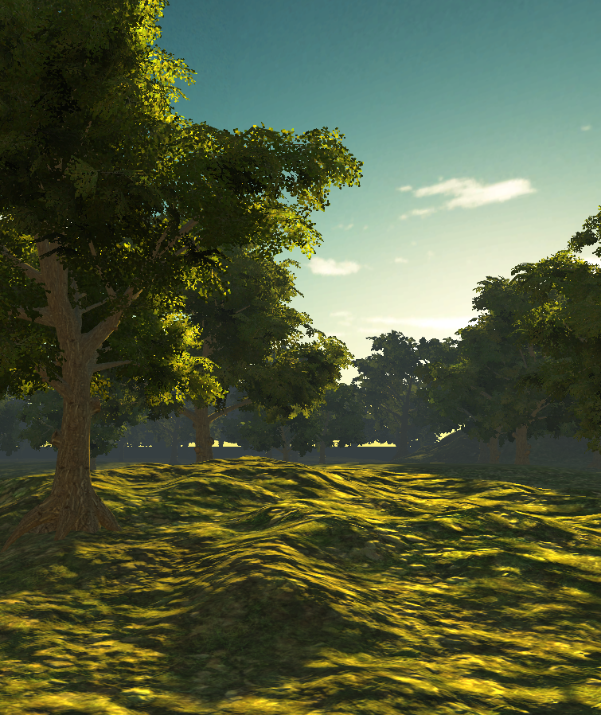

Today you are going to get a little taste of Unity. Work closely with a partner, just one ‘drives’ the machine while the other ‘navigates’ - reading and saying what to do next:

Open the demo as explained then run by clicking the play button. The program cannot run due to some programming bugs. The **PASS level challenge** is to fix the bugs that are stopping it from running.

1. Double click on the red error message at the bottom of the Unity editor window. A Script editor will eventually open showing the Rotator.cs script. It’s C# so you should recognise some of it.
2. Add the missing character to the end of line 15; read the error message for help.
3. Save the script [Ctrl+S]and go back to Unity. Another error has appeared in line 9. Errors are listed in the Console tab.
4. Change the data type of the variable declaration to match the literal value 16.5f ­   
   Search online for “C# data types” to get help.
5. Run the program again. You may want to listen through headphones if you have some available. Move the mouse.
6. Atmosphere is very important in games. Make some notes about what you see happening and perhaps hear in the scene. You should always have a pen and paper with you when you come to class.  
     
   _______________________________________________________  
     
   _______________________________________________________  
     
   _______________________________________________________  
     
   _______________________________________________________  
     
   _______________________________________________________  
     
   _______________________________________________________

Okay, so we can look around to some extent using the mouse, but the **MERIT challenge** is to walk around, instead of just spinning until we get dizzy! Firstly, swap seats so you both get a turn as driver and navigator.

1. 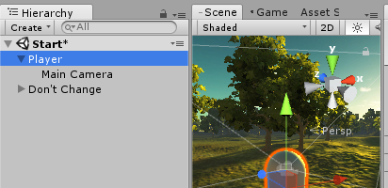Click on the Scene tab of the middle window. If you see a white capsule click on it, otherwise double click on Player in the Hierarchy pane to the left of the Scene view
2. Now look in the Inspector tab on the right and find the Rotator Script at the bottom. Untick the box to switch off that annoying script.
3. Now click on the Project tab below the hierarchy and open the script folder. You should see 4 script files with C# icons.
4. We are going to add the characterController script to the player. We can do that by dragging and dropping the script onto the word Player in the hierarchy view.
5. Run the program and try moving around using mouse and keyboard. This program has a logic error!
6. Open the script by double clicking on it in the project pane then see if you can fix the logic error on line 45.   
   It should help to look up transform.Translate in the Unity manual. Is the documentation installed
7. Make the player run by modifying the expression on line 52 to include another variable that the programmer, declared but forgot to use elsewhere. Remember that * is used for the multiply operation in programming. Notice how ‘public’ variables also appear and can be changed in the inspector as well as set by scripts.

Congratulations on getting this far. Swap seats again quickly. The **DISTINCTION** **challenge** isn’t too hard, but time is running out:

1. Find the hidden alien **artefact hidden** in the scene.
2. Now run the game and find the artefact in the orchard. Use your eyes and your ears to help you.
3. What happens when you touch it?
4. There is an unused script you could use to make the artefact significantly more interesting for the player. Do it and try it in play mode.
5. Play around with that script. Could you make it teleport the player instead, maybe to the as yet unwritten next level.